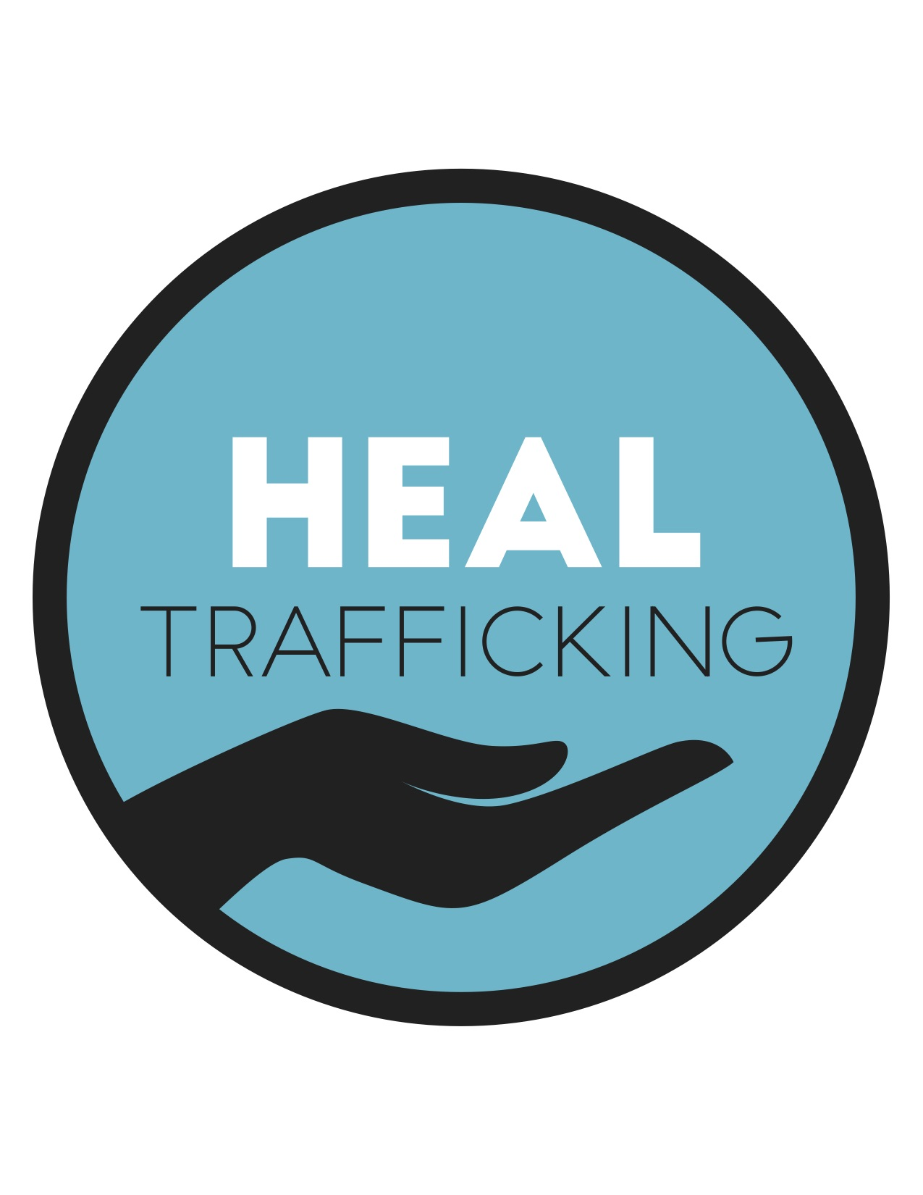
Dear Sir/Madam,

In response to Delta 8.7's public consultation to seek inputs to feed into the research and drafting of an upcoming report of the UN Special Rapporteur on Contemporary Forms of Slavery, Ms Urmila Bhoola, HEAL Trafficking submits the following information:

Founded in the fall of 2013, HEAL Trafficking is a united group of survivors and multidisciplinary professionals dedicated to ending human trafficking and supporting its survivors, from a public health perspective. HEAL Trafficking is a network of over 2600 survivors and professionals in 35 countries, including physicians, advanced practice clinicians, nurses, dentists, psychologists, counselors, public health workers, health educators, researchers, social workers, attorneys, administrators, and other professionals who work with and advocate for survivors of human trafficking. HEAL Trafficking works to mobilize a shift in the anti- trafficking paradigm toward approaches rooted in public health principles and trauma- informed care by expanding the evidence base; enhancing collaboration among multidisciplinary stakeholders; educating the broader anti-trafficking, public health, and health care communities; and advocating for policies and funding streams that enhance the public health response to trafficking and support survivors. HEAL Trafficking engages in work that combats all forms of human trafficking; supports trafficked people of all genders, ages, races/ethnicities, religions, origins, cultures, and sexual orientations; believes all trafficked persons deserve access to a full range of health care including medical, mental/behavioral health, reproductive health, dental, and substance use disorder treatment services; approaches human trafficking from a public health perspective that incorporates a socio-ecological framework and prevention strategies; and promotes a survivor-centered, trauma-informed, evidence-based, practice-based approach to anti-trafficking efforts.
HEAL Trafficking believes that efforts to eliminate trafficking in persons must incorporate a public health perspective.

We believe that the current approaches to human trafficking, largely grounded in a criminal justice framework will not allow us to reach SDG 8.7. We cannot arrest or prosecute our way out of trafficking. Rather, a public health approach, that looks upstream to tackle the underlying vulnerabilities to trafficking, is necessary to heal the world of trafficking. As a movement, we must also examine other movements to understand, and learn from the unintended consequences of interventions which had face validity, but failed to account for the complex interplay of structural inequities, racism, and all intersectional stakeholder communities.

Recommended reading (see attached):

Recknor, F. H., & Chisolm-Straker, M. (2018). Human Trafficking: It’s Not Just a Crime. Journal of Family Strengths, 18(1), 7.
https://digitalcommons.library.tmc.edu/cgi/viewcontent.cgi?article=1381&context=jfs

Please reach out with any clarifying questions.

